EXPERIMENT-1
import cv2
import matplotlib.pyplot as plt
img = cv2.imread("image.jpg", 0)
if img is None:
print("Image not found!")
else:
k = int(input("Enter kernel size (3, 5, or 7): "))
smooth = cv2.GaussianBlur(img, (k, k), 0)
plt.subplot(1, 2, 1)
plt.imshow(img, cmap="gray")
plt.title("Original Image")
plt.axis("off")
plt.subplot(1, 2, 2)
plt.imshow(smooth, cmap="gray")
plt.title("Smoothed Image")
plt.axis("off")
plt.show()
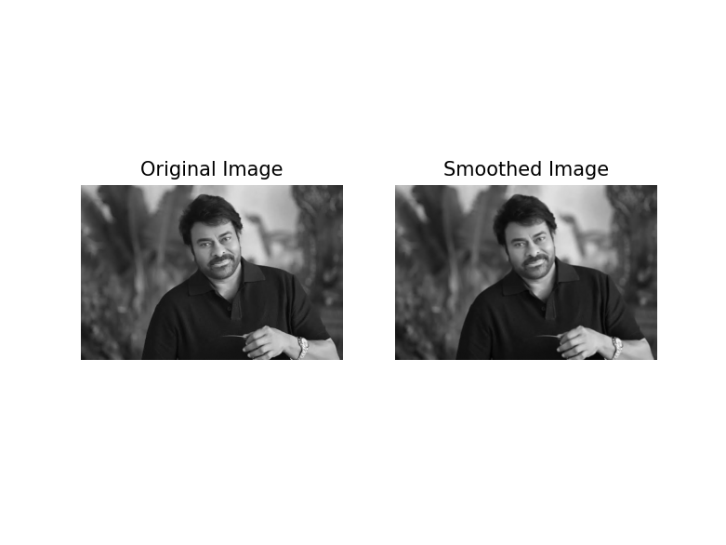
EXPERIMENT-2
import cv2
import matplotlib.pyplot as plt
import os
# Read the grayscale image
folder = os.path.dirname(os.path.abspath(__file__))
path = os.path.join(folder, "image.jpg")
img = cv2.imread(path, 0)
if img is None:
print("Error: Image not found!")
else:
# Apply histogram equalization
enhanced = cv2.equalizeHist(img)
# Display original image
plt.subplot(2, 2, 1)
plt.imshow(img, cmap="gray")
plt.title("Original Image")
plt.axis("off")
# Display enhanced image
plt.subplot(2, 2, 2)
plt.imshow(enhanced, cmap="gray")
plt.title("Enhanced Image")
plt.axis("off")
# Display original histogram
plt.subplot(2, 2, 3)
plt.hist(img.ravel(), bins=256, range=(0, 256))
plt.title("Original Histogram")
plt.xlabel("Pixel Intensity")
plt.ylabel("Frequency")
# Display equalized histogram
plt.subplot(2, 2, 4)
plt.hist(enhanced.ravel(), bins=256, range=(0, 256))
plt.title("Equalized Histogram")
plt.xlabel("Pixel Intensity")
plt.ylabel("Frequency")
# Adjust layout
plt.tight_layout()
# Display all results
plt.show()

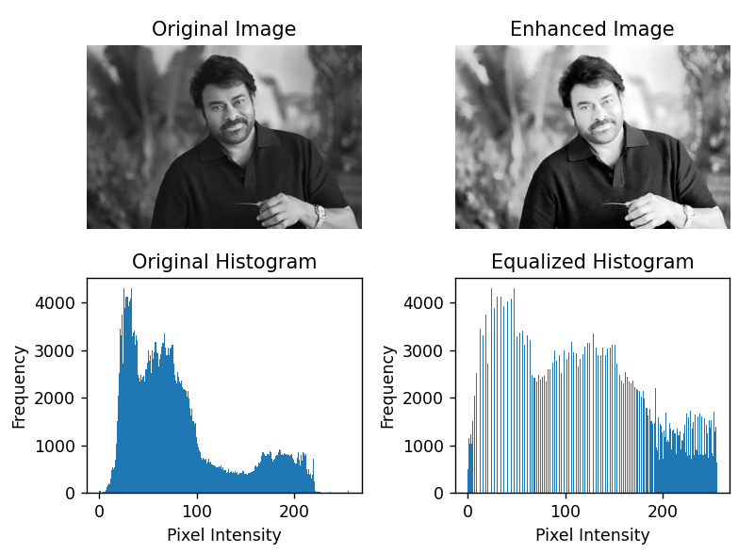
EXPERIMENT-3
import cv2
import matplotlib.pyplot as plt
import os

# Read the original image
folder = os.path.dirname(os.path.abspath(__file__))
path = os.path.join(folder, "image.jpg")

img = cv2.imread(path)

if img is None:
print("Error: Image not found!")
else:
# Convert BGR to RGB for Matplotlib
img = cv2.cvtColor(img, cv2.COLOR_BGR2RGB)

# Rotate clockwise by 90 degrees
rotate90 = cv2.rotate(img, cv2.ROTATE_90_CLOCKWISE)

# Rotate by 180 degrees
rotate180 = cv2.rotate(img, cv2.ROTATE_180)

# Rotate clockwise by 270 degrees
rotate270 = cv2.rotate(img, cv2.ROTATE_90_COUNTERCLOCKWISE)

# Display original image
plt.figure()
plt.imshow(img)
plt.title("Original Image")
plt.axis("off")

# Display 90-degree rotation
plt.figure()
plt.imshow(rotate90)
plt.title("90 Degrees Clockwise")
plt.axis("off")

# Display 180-degree rotation
plt.figure()
plt.imshow(rotate180)
plt.title("180 Degrees")
plt.axis("off")

# Display 270-degree rotation
plt.figure()
plt.imshow(rotate270)
plt.title("270 Degrees Clockwise")
plt.axis("off")

plt.show()

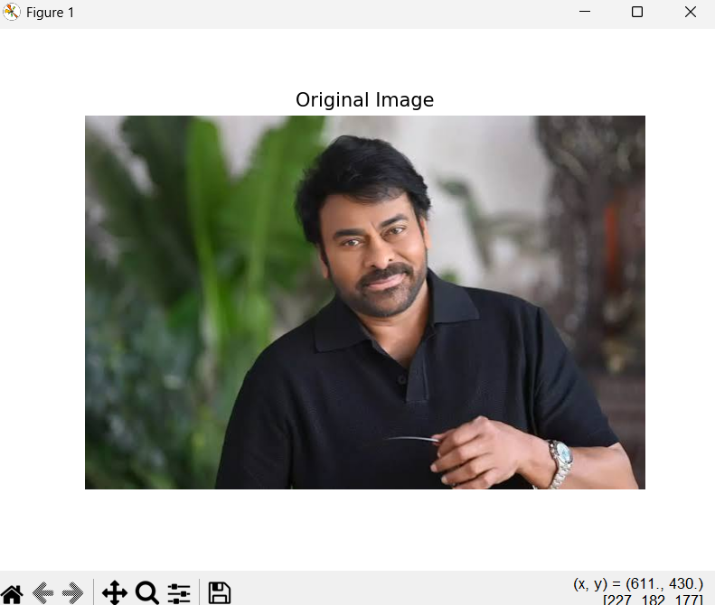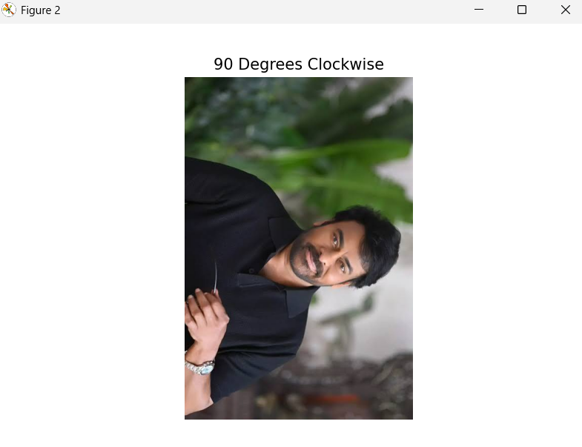
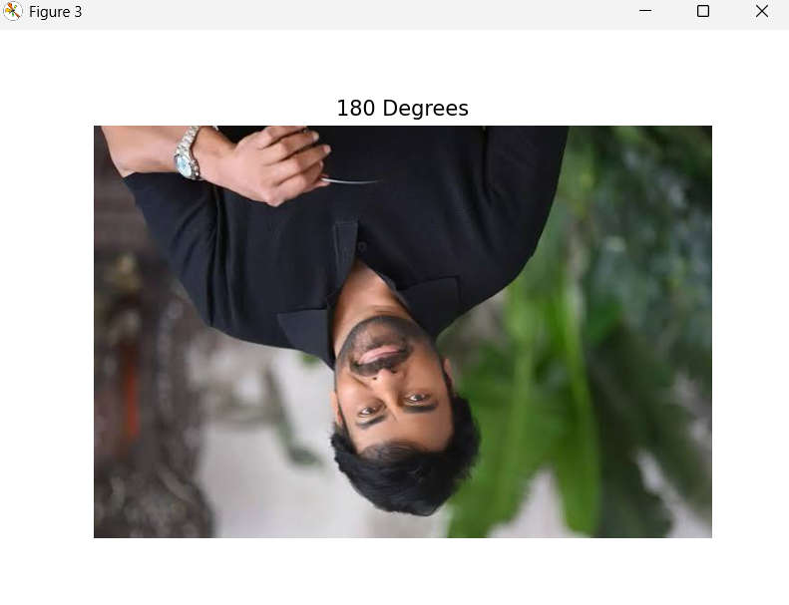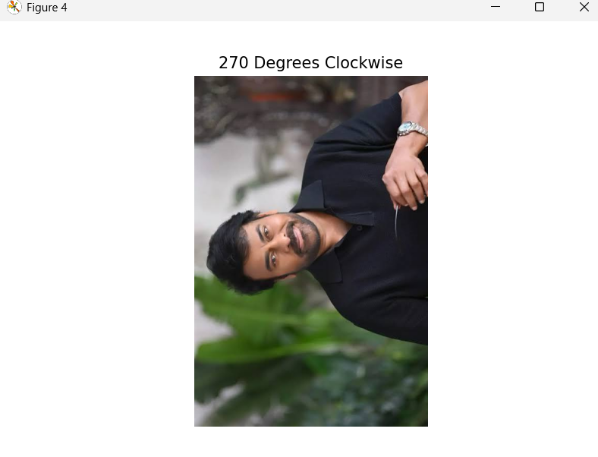
Experiment 4: Sobel-Based Edge Detection
import cv2
import numpy as np
import matplotlib.pyplot as plt
import os

# Read the grayscale image
folder = os.path.dirname(os.path.abspath(__file__))
path = os.path.join(folder, "image.jpg")

img = cv2.imread(path, 0)

if img is None:
print("Error: Image not found!")
else:
# Apply Sobel operator in X direction
sobel_x = cv2.Sobel(
img, cv2.CV_64F, 1, 0, ksize=3
)

# Apply Sobel operator in Y direction
sobel_y = cv2.Sobel(
img, cv2.CV_64F, 0, 1, ksize=3
)

# Convert gradient images to 8-bit format
abs_x = cv2.convertScaleAbs(sobel_x)
abs_y = cv2.convertScaleAbs(sobel_y)

# Combine horizontal and vertical gradients
magnitude = cv2.magnitude(sobel_x, sobel_y)

# Convert combined edge map to 8-bit format
edge_map = cv2.convertScaleAbs(magnitude)

# Display original image
plt.figure()
plt.imshow(img, cmap="gray")
plt.title("Original Image")
plt.axis("off")

# Display horizontal gradient
plt.figure()
plt.imshow(abs_x, cmap="gray")
plt.title("Sobel X - Vertical Edges")
plt.axis("off")

# Display vertical gradient
plt.figure()
plt.imshow(abs_y, cmap="gray")
plt.title("Sobel Y - Horizontal Edges")
plt.axis("off")

# Display combined edge map
plt.figure()
plt.imshow(edge_map, cmap="gray")
plt.title("Combined Edge Map")
plt.axis("off")
plt.show()
